**Day6 – Assignment1:**

**-----------------------------------------------------------------------------------------------------------------------------------**

**Problem**: Explain the Architecture of Git.

**Solution**:

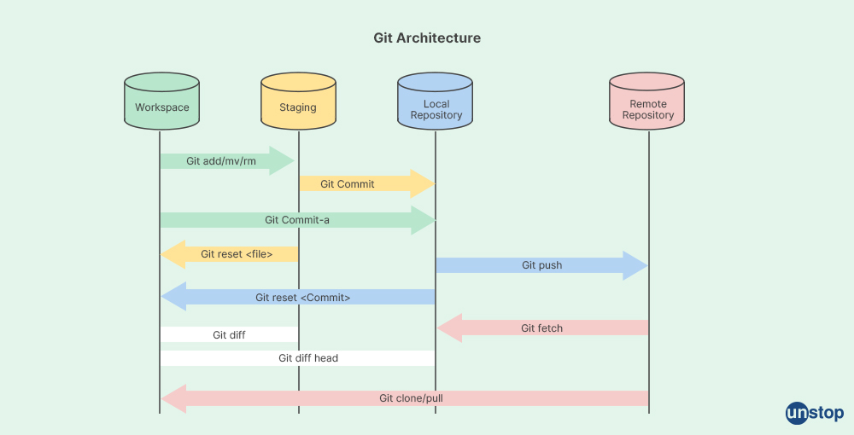

**Git Architecture:**

The architecture of Git revolves around several key components and how they interact to manage and version control source code and other files efficiently. Here's a breakdown of the architecture of Git:

**1. Workspace (Working Directory):**

The workspace, also known as the working directory, is where you edit and manipulate files. It's the directory on your local machine where you create, delete, modify, and organize your project files. These files are not automatically tracked by Git until you explicitly add them to the staging area.

**2. Staging Area (Index):**

The staging area, or index, is a crucial intermediate step between your workspace and the local repository. It serves as a buffer where you can selectively choose which changes (or snapshots) you want to include in your next commit. This allows you to craft commits that logically group related changes together before permanently saving them in the repository.

**3. Local Repository:**

The local repository is where Git stores all the committed changes and their complete history. It resides on your local machine and includes three main components:

* **Object Database**: Git stores each version of your files (snapshots) as objects in a highly efficient database. These objects include blobs (file contents), trees (directory structures), commits (snapshots with metadata), and tags (references to specific commits).
* **Branches**: Branches in Git are lightweight pointers to specific commits. They allow you to work on different features or versions of your project concurrently without affecting the main codebase. Each branch can diverge from the main development line (often called the master branch or main branch in modern Git workflows) and merge back when changes are ready.
* **HEAD**: HEAD is a reference to the currently checked-out commit in your repository. It points to the branch you're currently on, indicating where new commits will be added.

**4. Remote Repository:**

A remote repository is a version of your repository hosted on a remote server or another location accessible to collaborators. It serves as a shared repository where multiple developers can push their changes and pull changes from others. Key components of a remote repository include:

* **URL**: Remote repositories are identified by URLs (e.g., HTTPS or SSH URLs) that specify their location.
* **Branches**: Remote repositories contain branches that reflect the state of the project from other developers or contributors. These branches can be fetched (downloaded) or pushed (uploaded) to synchronize changes between the local and remote repositories.
* **Fetch/Pull and Push**: Fetching retrieves changes from the remote repository to your local repository without merging them automatically. Pulling combines fetching and merging changes into your current branch. Pushing sends your committed changes from your local repository to the remote repository.

**5. Objects:**

Git stores data as a series of snapshots of the repository at different points in time. Each snapshot is represented as an object. There are several types of objects in Git:

1. **Blob:** A blob object stores file data (contents of files).
2. **Tree:** A tree object represents a directory. It contains pointers to blobs (file contents) and other trees (sub-directories).
3. **Commit:** A commit object points to a specific snapshot of the repository at a given point in time. It includes metadata like the author, commit message, timestamp, and most importantly, references to the tree object that represents the state of the repository at that point.

**6. Branches:**

Git allows for branching, which is the practice of diverging from the main line of development and continuing work without altering the main codebase. Branches are lightweight and easy to create, enabling developers to work on features or fixes independently.

**7. References:**

Git uses references (refs) to keep track of commits. The main reference is the HEAD, which points to the currently checked out branch or commit. Branches are essentially movable pointers to commits, making it easy to switch between different lines of development.

**8. Operations:**

Git provides a set of operations to manipulate the repository and its history. Key operations include:

1. **Commit:** Create a snapshot of the repository.
2. **Checkout:** Switch between branches or restore files from commits.
3. **Merge:** Combine changes from different branches.
4. **Rebase:** Move or combine a sequence of commits to a new base commit.

**9. Distributed:**

Git is a distributed version control system (DVCS), meaning each developer has a complete copy of the repository with its full history. This decentralization enables offline work, fast branching and merging, and robustness against repository corruption.

**Interaction Flow:**

The typical interaction flow in Git involves:

1. **Modifying Files**: Make changes to files in your workspace (working directory).
2. **Staging Changes**: Use git add to stage changes selectively in the staging area/index.
3. **Committing Changes**: Use git commit to create a snapshot of the staged changes in your local repository.
4. **Managing Branches**: Use git branch to create, delete, or switch branches for different lines of development.
5. **Syncing with Remote**: Use git fetch, git pull, and git push to interact with remote repositories, synchronize changes, and collaborate with others.

**Benefits of Git Architecture:**

* **Flexibility**: Supports branching and merging for parallel development workflows.
* **Scalability**: Handles large repositories and extensive histories efficiently.
* **Distributed**: Every developer has a complete copy of the repository, enabling offline work and robust collaboration.

Overall, Git's architecture is designed to be flexible, efficient, and scalable, supporting both small projects and large-scale development workflows. Its distributed nature and focus on snapshots make it powerful for version control and collaboration in software development.